TASK 1
BY FERDAUS
WordPress Gutenberg Block
Front-End Technical Plan — Front-End / WordPress Block API

Overview:-
This document explains how the interactive Todo List block is implemented using the WordPress Block API and REST API. The goal is to allow users to create, update, and delete todos without reloading the page, while keeping all data stored on the server.

Instead of relying on browser storage, all todos are saved via the WordPress REST API. This keeps the data consistent across refreshes, devices, and sessions.

Plugin File Structure:-

Suppose My Folder Layout:
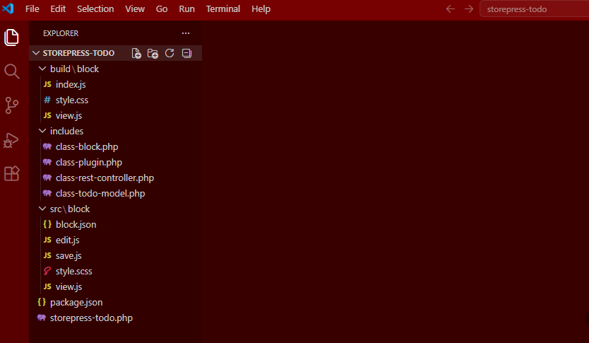

File Details:
File | Responsibility
storepress-todo.php | Acts as the entry point of the plugin. It loads required classes, registers activation hooks, and initializes the plugin.
class-plugin.php | Handles initialization and registers hooks such as REST routes, block registration, and script loading.
class-todo-model.php | Responsible for all database operations using $wpdb, including insert, update, delete, and fetch queries.
class-rest-controller.php | Defines REST API routes and handles requests. Also responsible for validation, sanitization, and permission checks.
class-block.php | Registers the block and defines the render callback used to output the block on the frontend.
src/block/edit.js | Provides a preview of the block inside the editor. This is not interactive and is only used for visual representation.
src/block/save.js | Returns null since this is a dynamic block rendered via PHP.
src/block/view.js | Handles frontend interactivity such as adding, updating, and deleting todos using the Interactivity API.

Database Design:-

Why a Custom Table?
Custom Post Type | Custom Table
Adds revisions, terms, meta overhead | Purpose built, only needed columns
WP_Query slower for simple lists | Direct $wpdb queries fast and predictable
Post statuses not suited to todo logic | ('pending, complete') semantically correct
Per user scoping is complex | user_id column, native, clean, indexed

Table Schema: {prefix}_sp_todos
Column | Type | Constraint | Purpose
id | BIGINT UNSIGNED | AUTO_INCREMENT | Unique row identifier
title | TEXT | NOT NULL | The todo text content
status | Pending, complete | DEFAULT | Current state of the todo
user_id | UNSIGNED | NOT NULL | WordPress user ID owner of the todo
created_at | DATETIME | DEFAULT NOW() | Timestamp when created
updated_at | DATETIME | ON UPDATE NOW() | Timestamp of last modification

Table Creation Code:
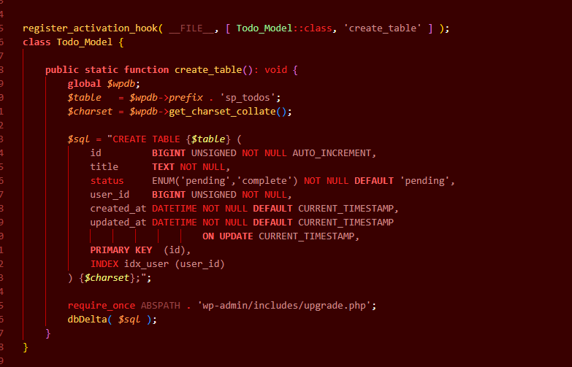

REST API Design:-
All data operations use REST endpoints registered with register_rest_route() under the namespace storepress/v1. The frontend never touches the database directly.

Endpoints:
Method | Endpoint | Permission | Action
GET | /storepress/v1/todos | is_user_logged_in() | Fetch all todos for current user
POST | /storepress/v1/todos | is_user_logged_in() | Create a new todo
PUT | /storepress/v1/todos/{id} | is_user_logged_in() | Update title or toggle status
DELETE | /storepress/v1/todos/{id} | is_user_logged_in() | Delete a todo by ID

Security:-
- Requests are protected using a nonce generated with wp_localize_script
- All API calls include the nonce via headers
- Only logged-in users can access the endpoints
- Input is sanitized before use
- Queries are scoped by user_id so users can only access their own data

REST Controller:
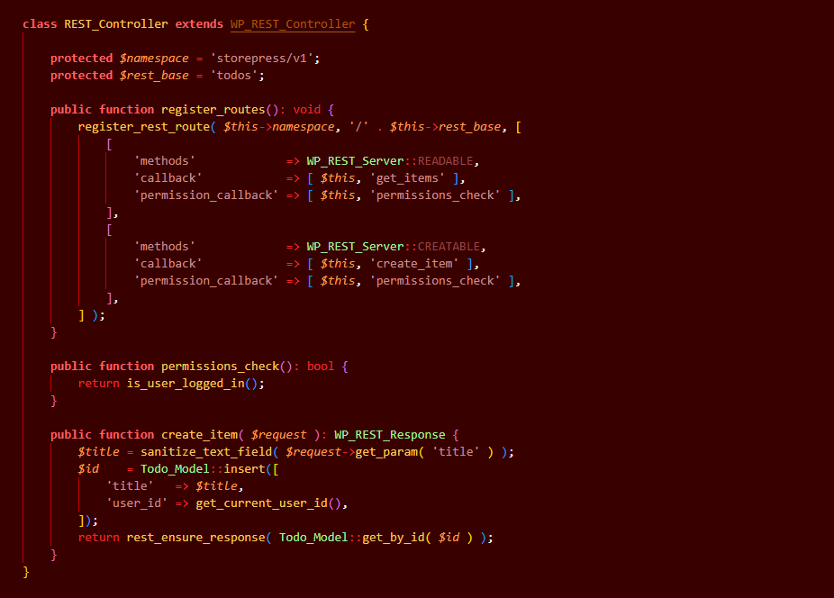

Interact & State Manage:-

Why do we use @wordpress/interactivity?
The frontend uses WordPress official @wordpress/interactivity for handling dynamic behavior. This keeps the frontend lightweight while still allowing reactive updates.

Alternative Approaches | @wordpress/interactivity
Vanilla JS and fetch() not WordPress native | WordPress official standard for WP 6.6 blocks
Full React on frontend heavy bundle | Lightweight only reactive directives
jQuery deprecated in modern WP stack | Works with WP server side rendering
localStorage no cross device sync | Server side persistence via REST API

Structure (view.js):
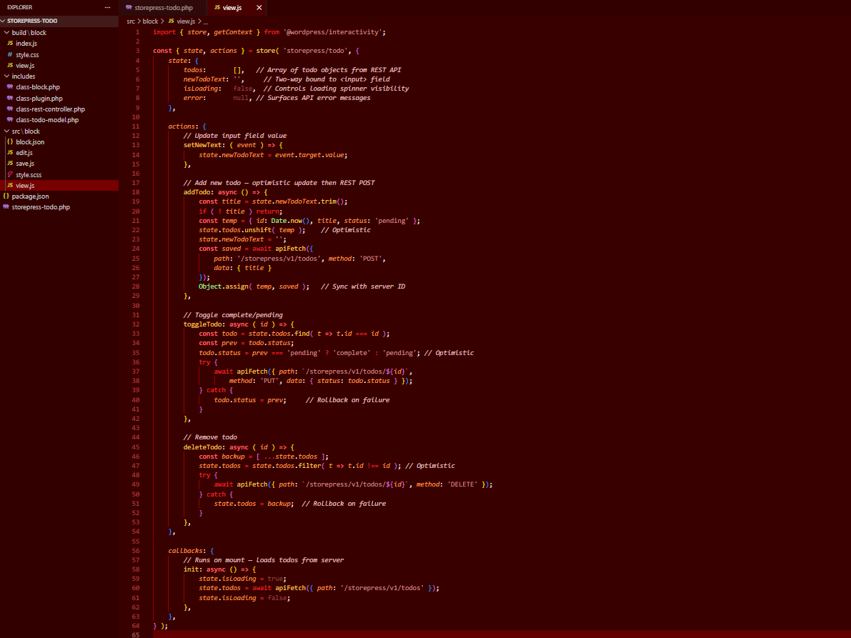

Update:
User clicks action (add/toggle/delete) | -> | UI updates immediately (optimistic state) | -> | REST API call in background -> success = fail = rollback

Block Registration (PHP):-

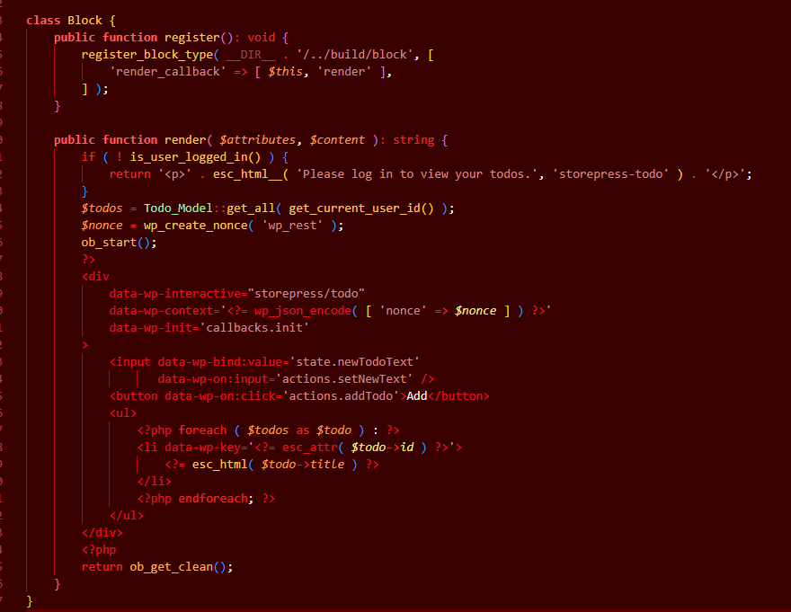

Block.json Attributes & Metadata:-
The block is registered using register_block_type() with a render callback. The HTML is generated server-side, and interactivity is added using data attributes.

Complete block.json
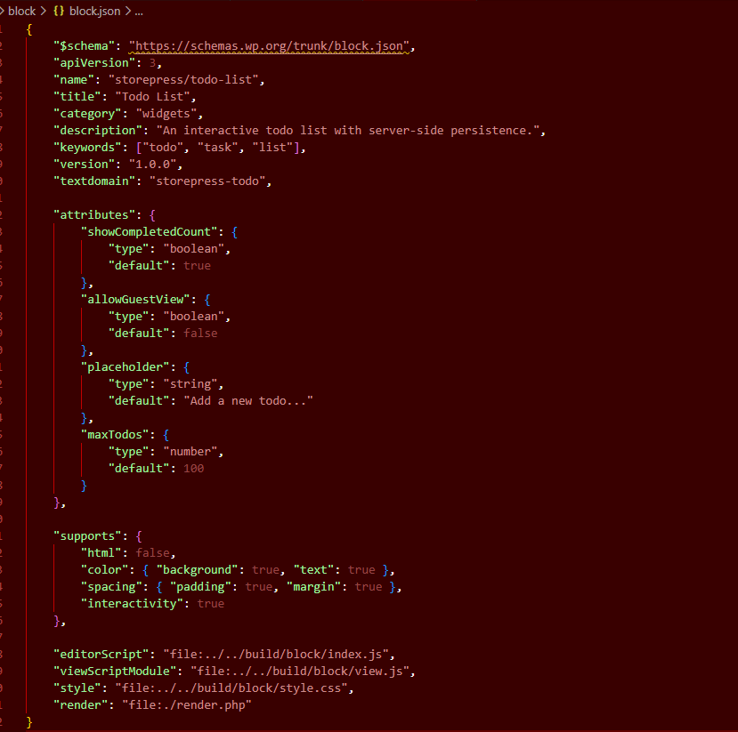

Attributes:
Attribute | Type | Purpose
showCompletedCount | boolean | Shows summary above the list
allowGuestView | boolean | If true, logged-out users can view todos
placeholder | string | Customisable input placeholder text editable in Block Inspector
maxTodos | number | Maximum todos per user prevents DB bloat

Error Handling:-
In my plans for failure network drops, server errors, permission issues. Every REST call has a defined error path with both UI feedback and state rollback.

Error Types & Responses
Error | HTTP Code | User Response
Network failure | ……….. | Connection lost. My change was not saved.
Unauthorised | 401 | Redirect to wp-login.php session likely expired
Forbidden | 403 | I do not have permission to do this.
Not found | 404 | Remove stale item from local state silently
Validation error | 422 | Inline field error Todo title cannot be empty.
Server error | 500 | Something went wrong. Please try again.

Error Handling in view.js
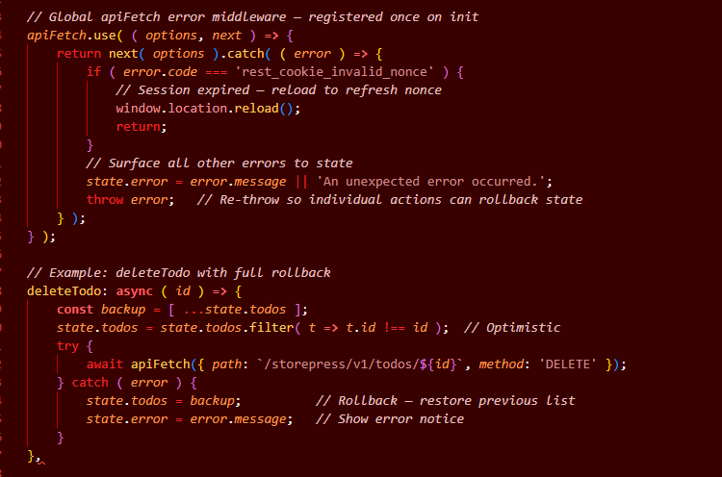
Every optimistic state change stores a backup snapshot before the API call. On catch, the snapshot is restored. The user always sees a consistent UI, never a broken or half-updated state.

Scalability:-
My thoughts are beyond the happy path. Below are the scalability considerations and edge cases planned for this implementation.

Pagination Lists:
If a user has hundreds of todos, loading all of them at once is wasteful. The REST API will support server side pagination from day one.
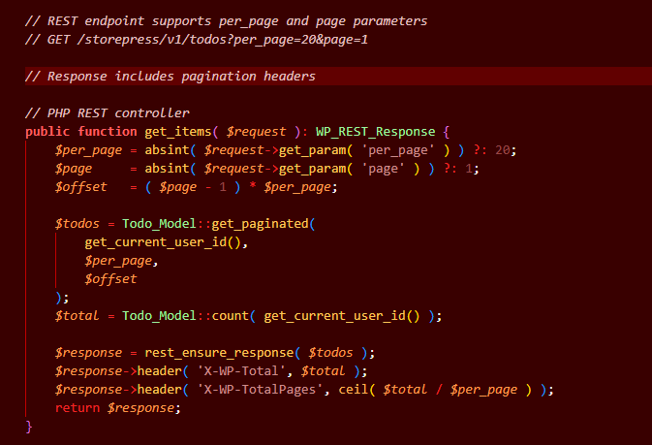

Edge Handled:
Edge | How It's Handle
Empty todo title submitted | Client side button disabled if input empty. Server side validation error returned
User not logged in | render_callback shows 'Please log in' message. REST returns 401
User tries to edit another's todo | user_id scoping in all DB queries can only access own todos
Duplicate rapid clicks | Button disabled during API call prevents duplicate submissions
Todo title > safe length | DB column is TEXT but REST validates args schema
maxTodos limit reached | REST returns with message 'Todo limit reached' UI shows notice
Plugin deactivation | Deactivation hook does NOT drop table data preserved. Uninstall hook drops it
WordPress multisite | Table created per-site using $wpdb->prefix each site has its own todos

DB Index:-
The custom table has a dedicated index on user_id this ensures queries stay fast even with tens of thousands of rows across all users.

Testing:-
A production ready plugin requires a testing strategy at multiple levels from isolated unit tests to full browser based end to end tests.

Testing
Level | Tool | Tested
PHP | PHPUnit + WP Test | CRUD methods, REST controller callbacks, sanitization logic
JS | @wordpress/jest-preset-default | Interactivity store actions, apiFetch mock responses
Integration | WP + PHPUnit | REST registration, permission callbacks, nonce verification
End to End | Playwright / @wordpress/e2e-test-utils | Appears on page, toggle persists on refresh

Sample PHP Test
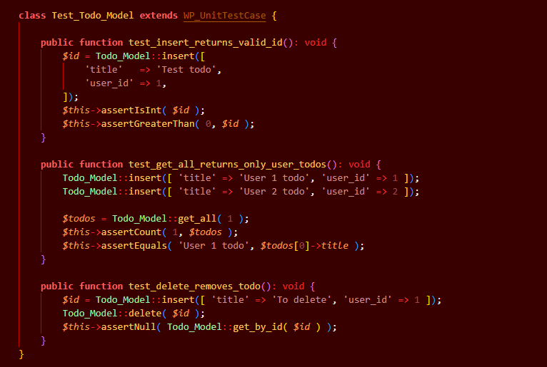

Sample JS Test:
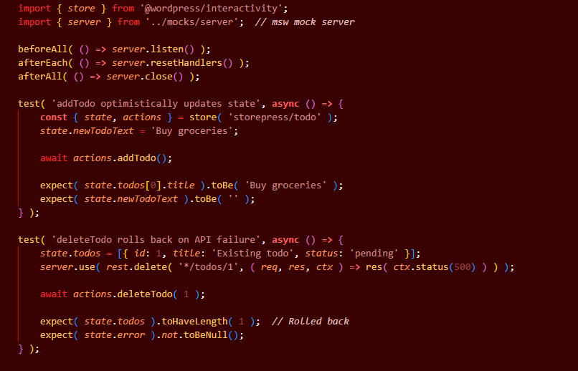

Tech Stack -> Task 1
Layer | Technology
Build Tooling | @wordpress/scripts (Webpack)
Block API | register_block_type() dynamic block with render callback
Frontend React | @wordpress/interactivity
HTTP Client | @wordpress/api-fetch WP native, auto attaches nonce
REST Layer | WP_REST_Controller + register_rest_route()
Database | $wpdb + custom table
Security | wp_create_nonce(), permission_callback, sanitize_text_field()

